QUESTION 1.

#include <stdio.h>

#include <stdlib.h>

int main()

{

printf("my first program!\n");

return 0;

}

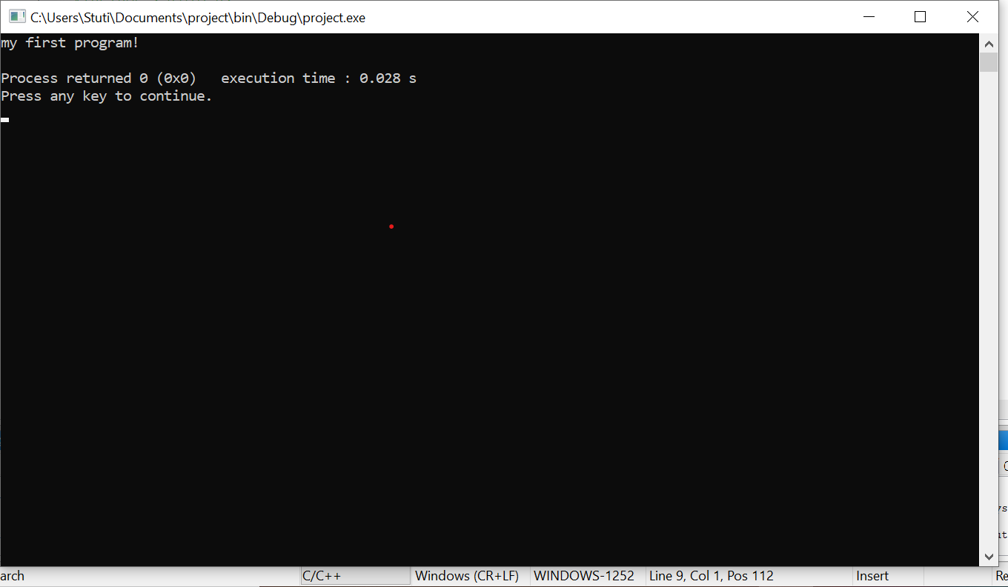

QUESTION 2.

#include<stdio.h>

int main()

{

int x,y,sum ;

printf("enter first number:");

scanf("%d",&x);

printf("enter second number:");

scanf("%d",&y);

sum=x+y;

printf("sum of 2 numbers:%d ",sum);

return 0;

}

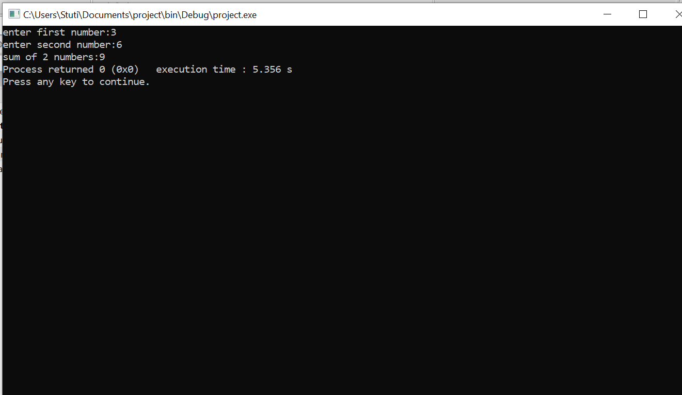

QUESTION 3.

#include<stdio.h>

int main()

{

int radius ;

float area;

printf(“Enter radius of the circle”);

scanf(“%d,&radius);

area=3.14\*radius\*radius;

printf(“Area if the circle =”%f square inches \n”, area);

return 0;

}

QUESTION 4 .

#include <stdio.h>

int main()

{

int num1 , num2 ;

int sum, sub, mult;

float div;

printf("Enter any two numbers : );

scanf("%d,%d", &num1 , &num2 );

sum= num1 +num2 ;

sub=num1-num2;

mult= num1\*num2;

div=(float)num1/num2;

printf("The sum of the two given number is : %d\n", sum);

printf("The difference of the two given number is :%d\n" ,sub);

printf("The product of the two given number is :%d\n" , mult);

printf("The quotient of the two given number is : %f\n", div);

return 0 ;

}

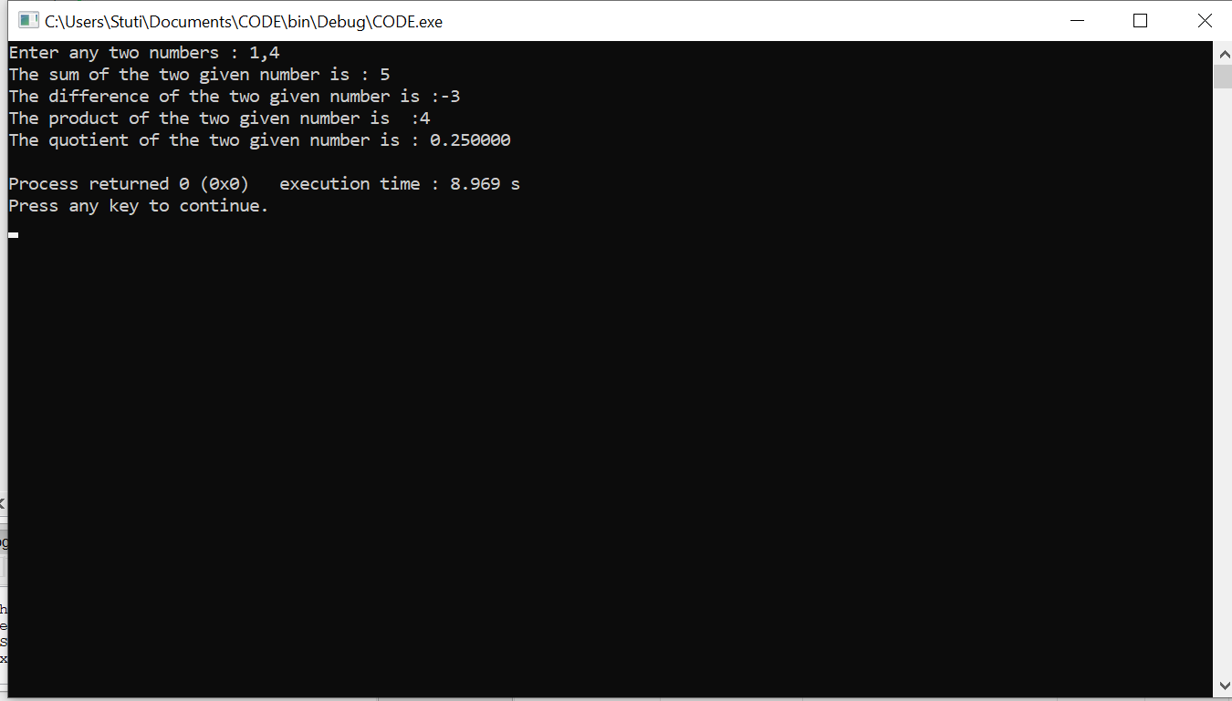

QUESTION 5 .

#include<stdio.h>

int main()

{

int divident , divisor , quotient, remainder ;

divident=15 ;

divisor=2;

quotient = divident/divisor;

remainder= divident%divisor;

printf("Quotient = %d\n",quotient);

printf("Remainder=%d\n",remainder);

return 0;

}

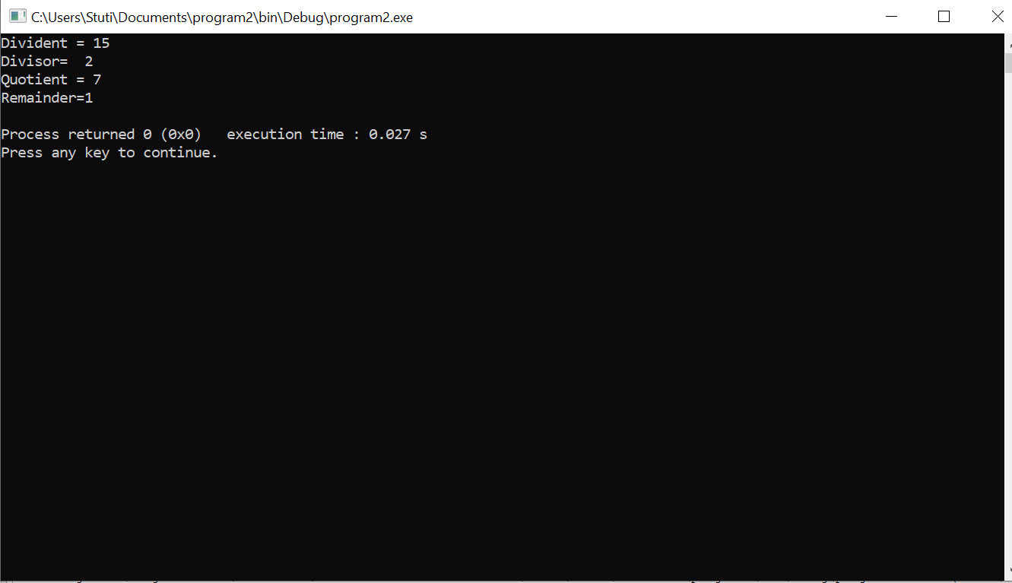

QUESTION 6.

#include<stdio.h>

int main()

{

int x=12 , y=6 ;

printf ("Value of x before swapping is : 12\n");

printf ("Value of y before swapping is : 6\n");

x=x+y;

y=x-y;

x=x-y;

printf("Value of x after swapping : x=%d\n", x);

printf("Value of y after swapping : y=%d\n" , y);

return 0;

}

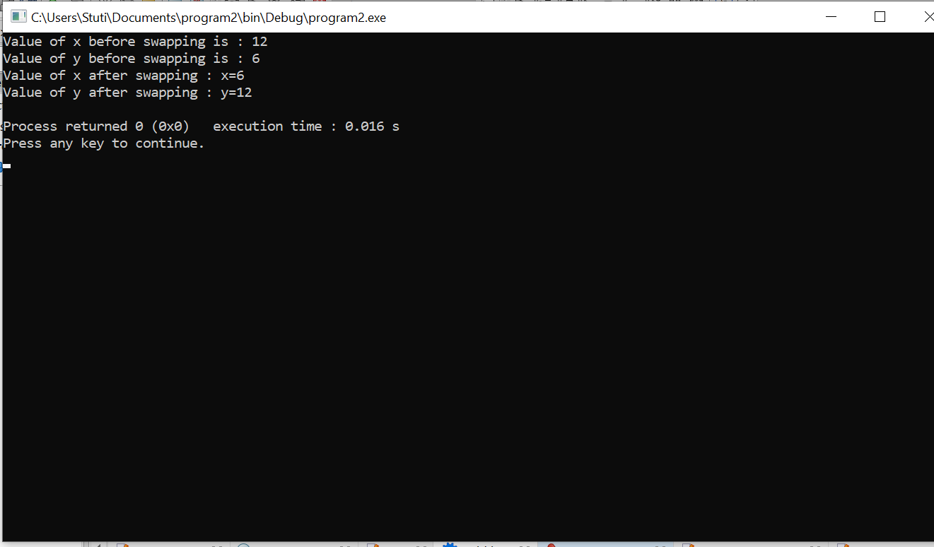

QUESTION 7.

#include<stdio.h>

int main()

{

int num , denom;

printf("Enter numerator of the rational number \n");

scanf("%d" , &num);

printf("Enter denominator of the rational number ");

scanf("%d",&denom);

int n1,n2,n3,d1,d2,d3;

n1=num\*2;

n2=num\*3;

n3=num\*4;

d1=denom\*2;

d2=denom\*3;

d3=denom\*4;

printf("Equivalent rational number of %d/%d is %d/%d,%d/%d,%d/%d", num,denom,n1,d1,n2,d2,n3,d3);

return 0;

}

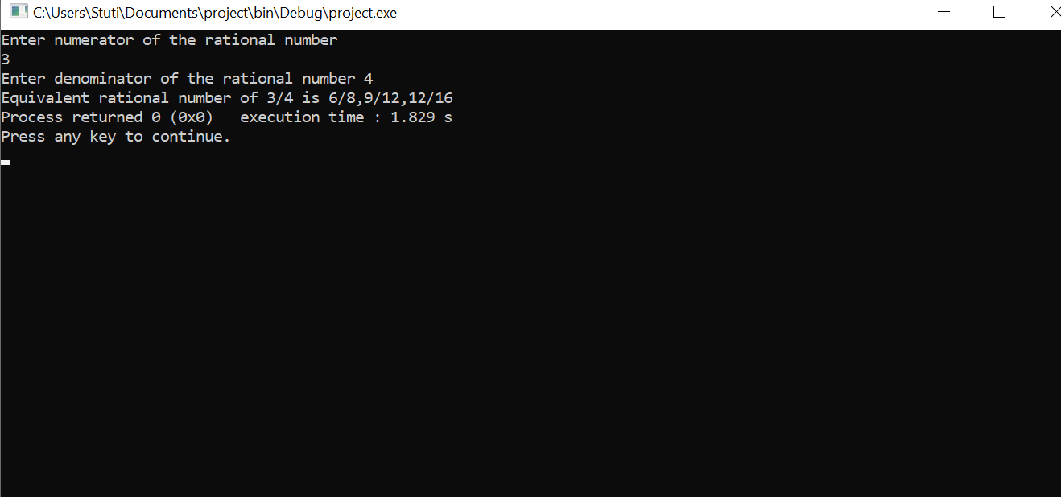

QUESTION 8.

#include <stdio.h>

int main() {

float x1, y1, x2, y2, distance;

printf("Input x1: ");

scanf("%f", &x1);

printf("Input y1: ");

scanf("%f", &y1);

printf("Input x2: ");

scanf("%f", &x2);

printf("Input y2: ");

scanf("%f", &y2);

distance = ((x1-x2)\*(x1-x2))+((y1-y2)\*(y1-y2));

printf("Distance between the said points: %.4f", sqrt(distance));

printf("\n");

return 0;

}

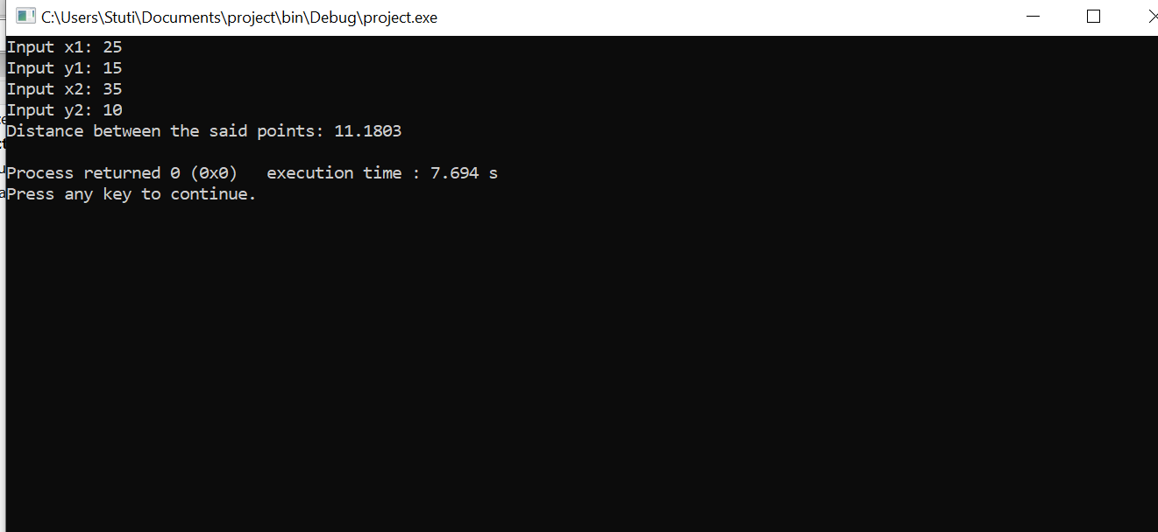

QUESTION 10.

#include <stdio.h>

int main()

{

int n, rev = 0, remainder;

printf("Enter an integer: ");

scanf("%d", &n);

while(n != 0)

{

remainder = n % 10;

rev = rev \* 10 + remainder;

n /= 10;

}

printf("Reversed number = %d", rev);

return 0;

}

